DIS-MEX-Moche-Stirrup vessel

Value $7,000 – $9,000

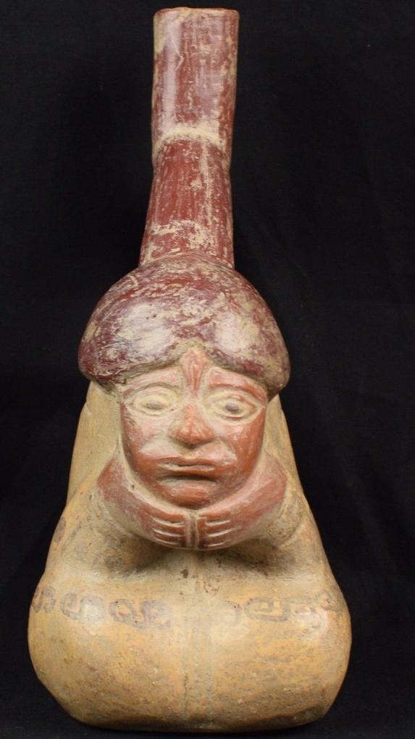 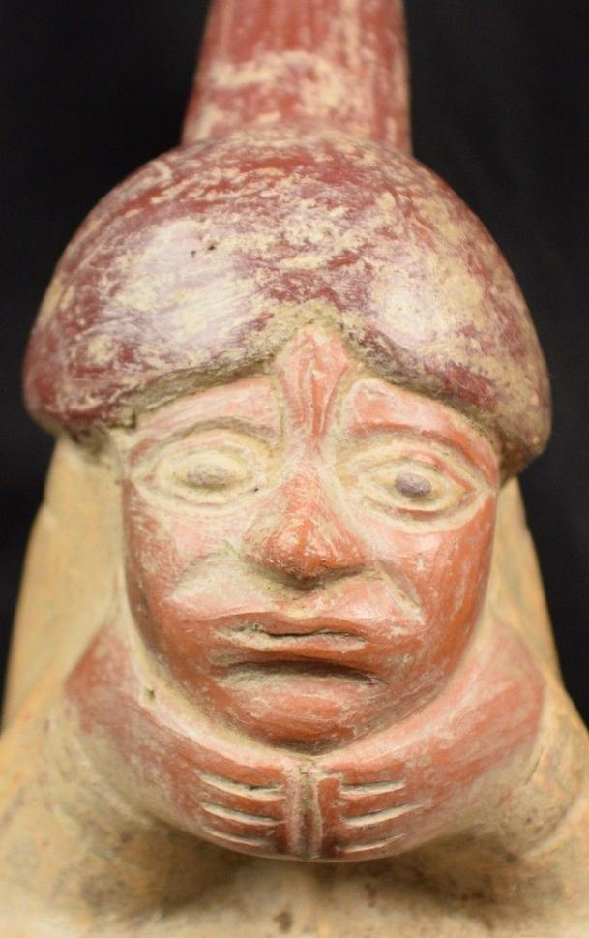 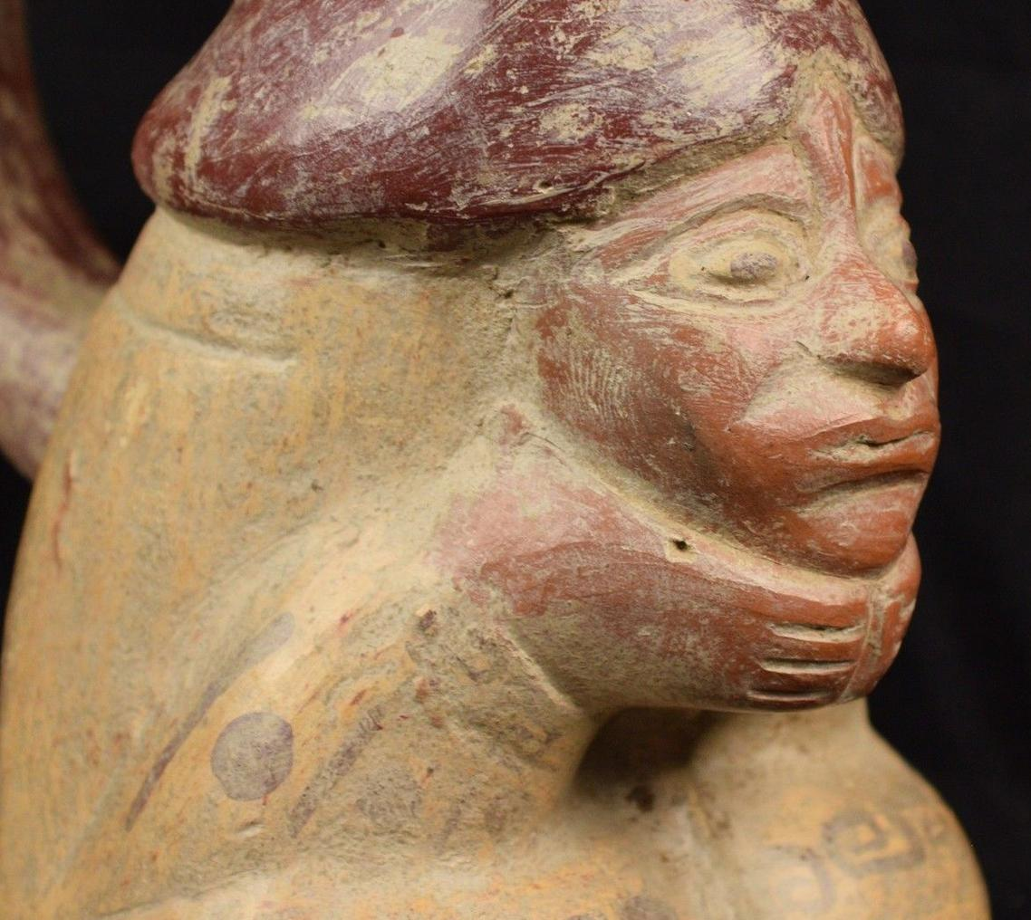 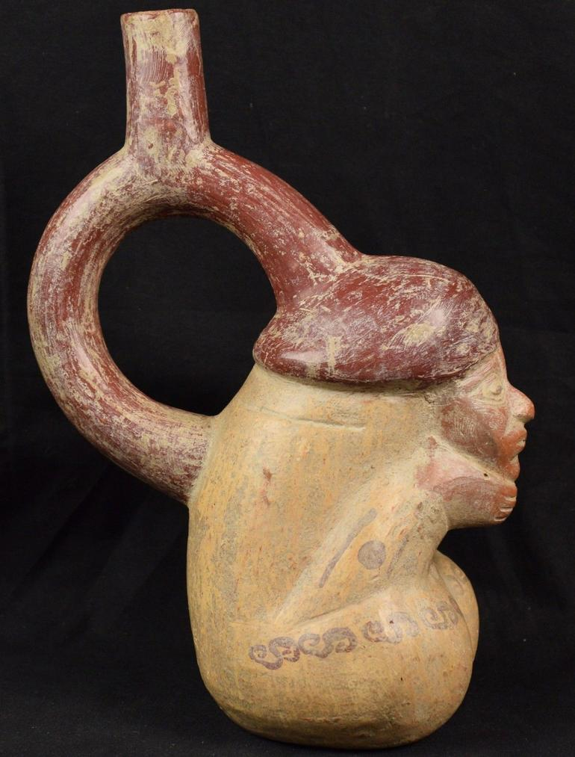 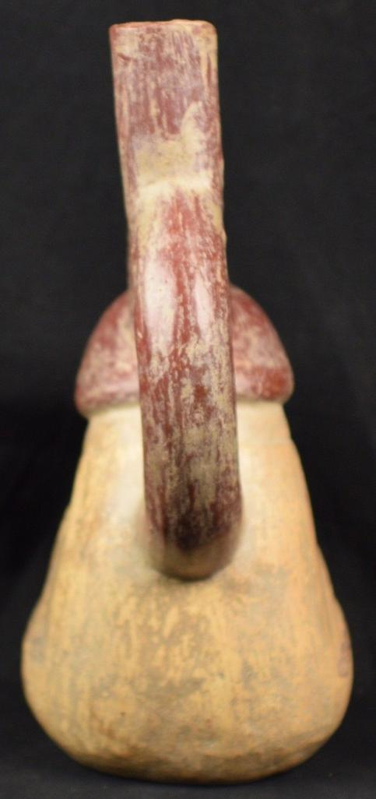 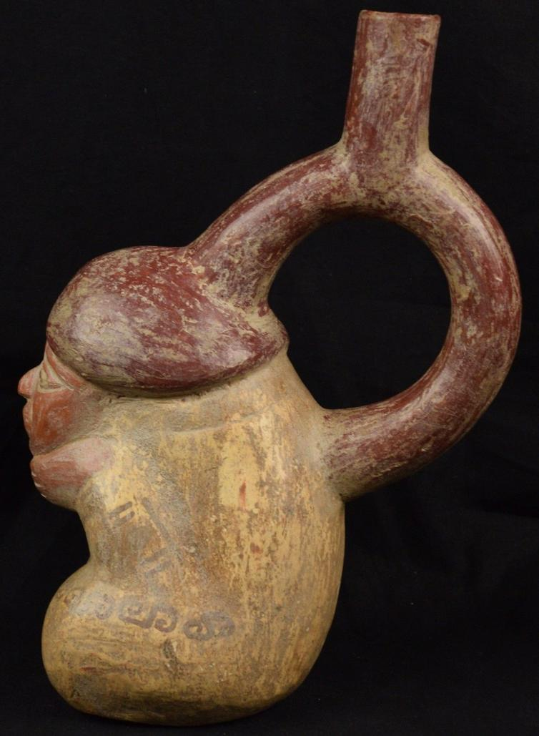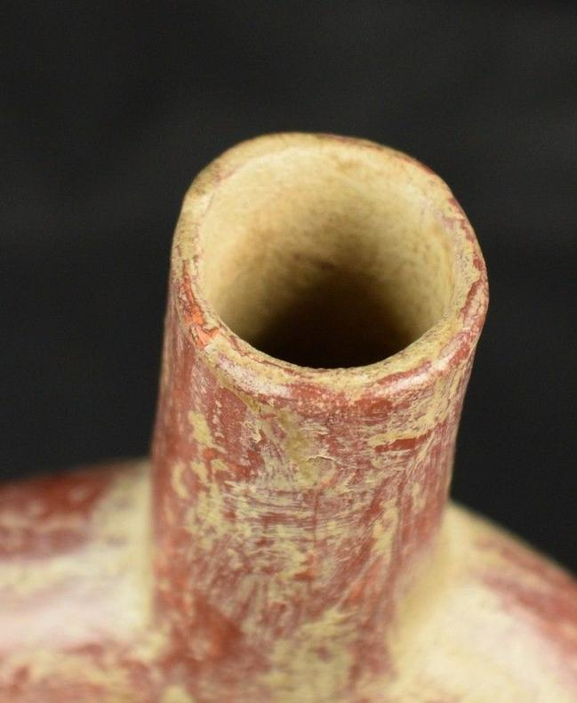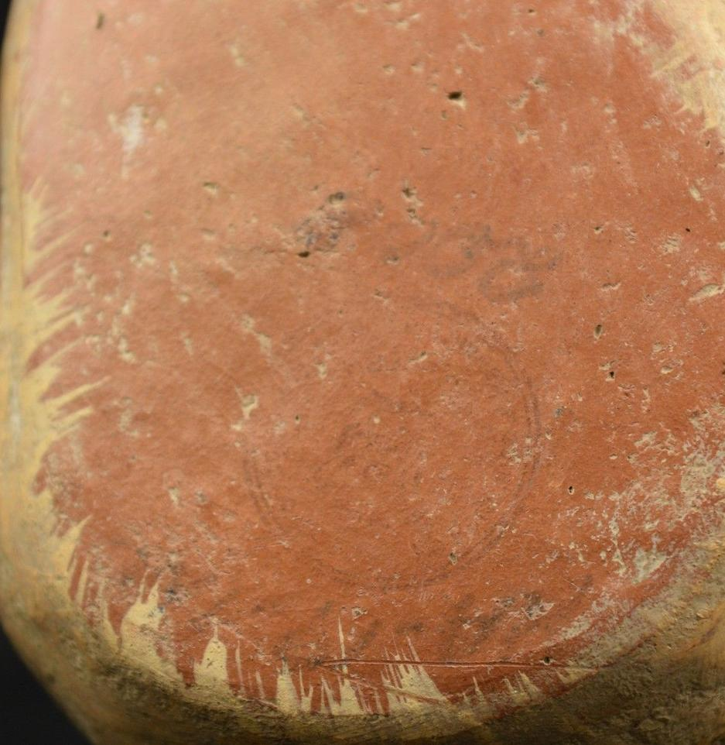

|  |  |
| --- | --- |
| ORDER DATEMar 09, 2016 | ORDER TOTAL  US $74.95  + US $9.45  shipping  **Order Pre Columbian Vessel Human Figure Replica? Unknown** [Leave feedback - ORDER DATE Mar 09, 2016](http://feedback.ebay.com/ws/eBayISAPI.dll?LeaveFeedbackShow&useridto=goldensestateservices2&transactID=1378571360006&item=162002468567&_trksid=p2057872.m2749.l2665)[View order details](http://payments.ebay.com/ws/eBayISAPI.dll?ViewPaymentStatus&transId=1378571360006&itemid=162002468567&_trksid=p2057872.m2749.l2673) - ORDER DATE Mar 09, 2016  [More actions - ORDER DATE Mar 09, 2016](http://www.ebay.com/myb/PurchaseHistory) |

1 item sold by [goldensestateservices2](http://www.ebay.com/usr/goldensestateservices2?_trksid=p2057872.m2749.l2754)

|  |  |
| --- | --- |
| [Pre Columbian Vessel Human Figure Replica? Unknown](http://www.ebay.com/itm/162002468567?_trksid=p2057872.m2749.l2649&ssPageName=STRK%3AMEBIDX%3AIT)  ( 162002468567 )  Delivered on Tue, Mar 15  Tracking number: [**Tracking number**9405509699937405340069](javascript:;)  [Add note](javascript:;) | ITEM PRICE:  US $74.95 |